**Multitier Website**

**Name: samata salunke**

**Description:**

Amazon Elastic Compute Cloud (Amazon EC2) provides scalable computing

capacity in the Amazon Web Services (AWS) cloud. Using Amazon EC2

eliminates your need to invest in hardware up front so you can develop and

deploy applications faster. You can use Amazon EC2 to launch as many or as

few virtual servers as you need, configure security and networking, and manage

storage. Amazon EC2 enables you to scale up or down to handle changes in

requirements or spikes in popularity, reducing your need to forecast traffic.

**Problem Statement:**

Company ABC wants to move their product to AWS. They have the following

things set up right now:

1. MySQL DB

2. Website (PHP)

The company wants high availability on this product, therefore wants Auto

Scaling to be enabled on this website.

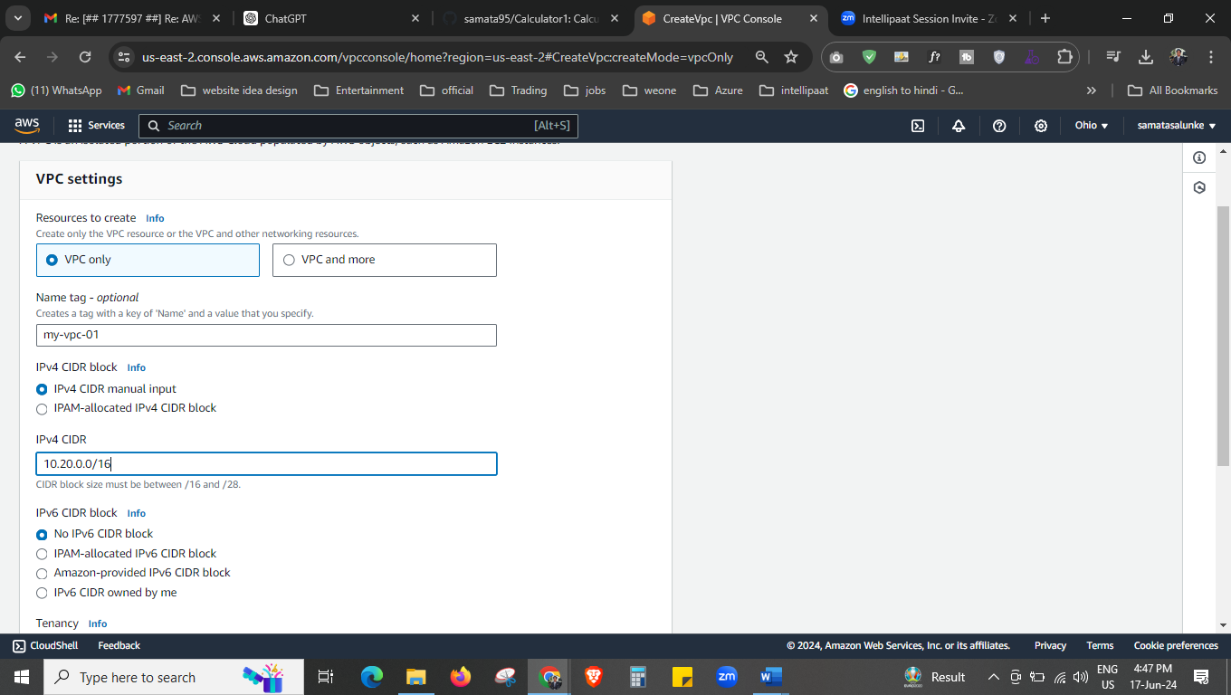

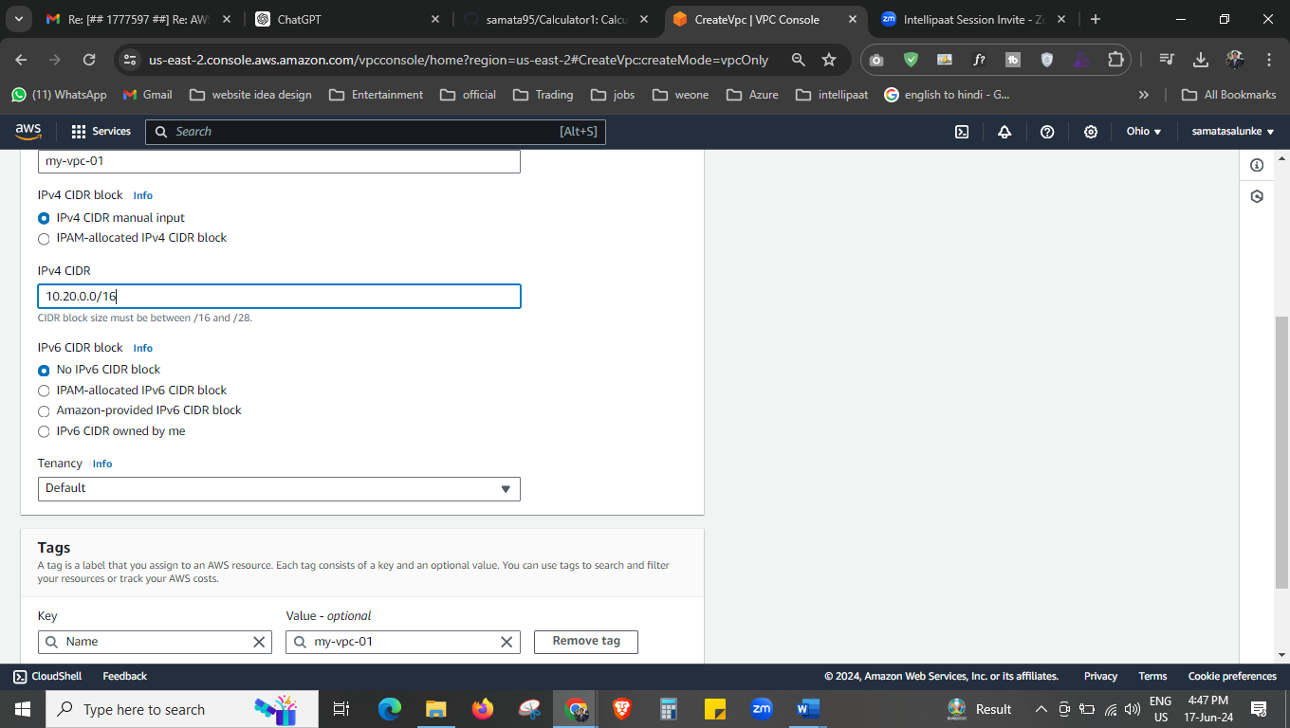

Create the vpc

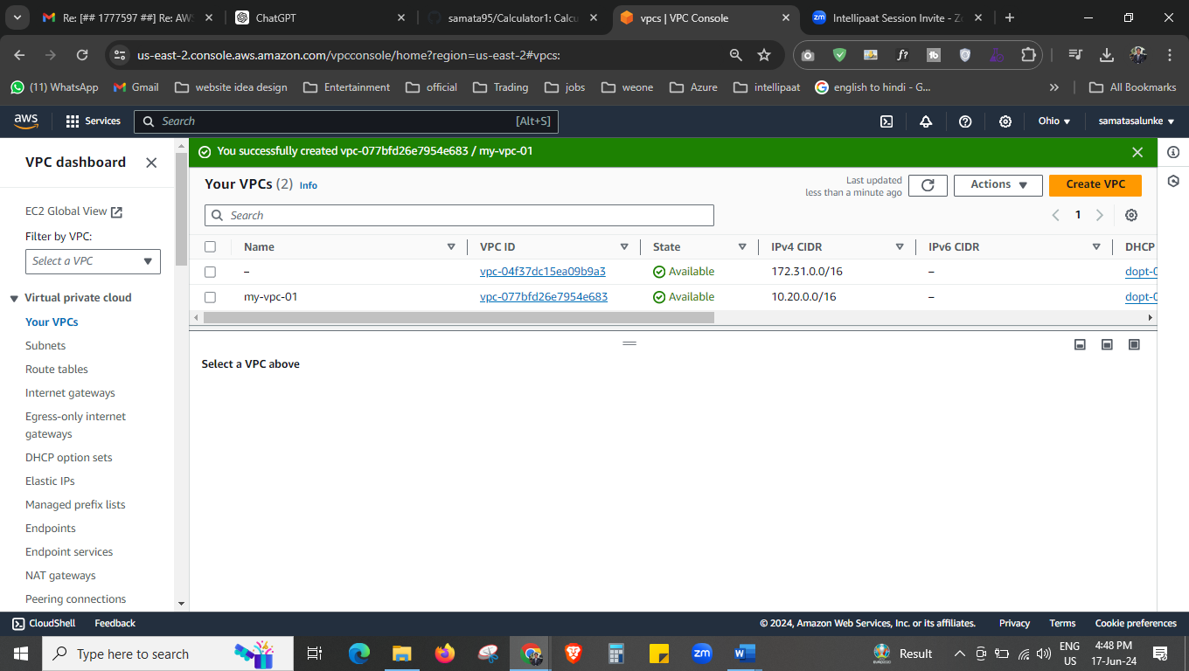



Our vpc is created now.

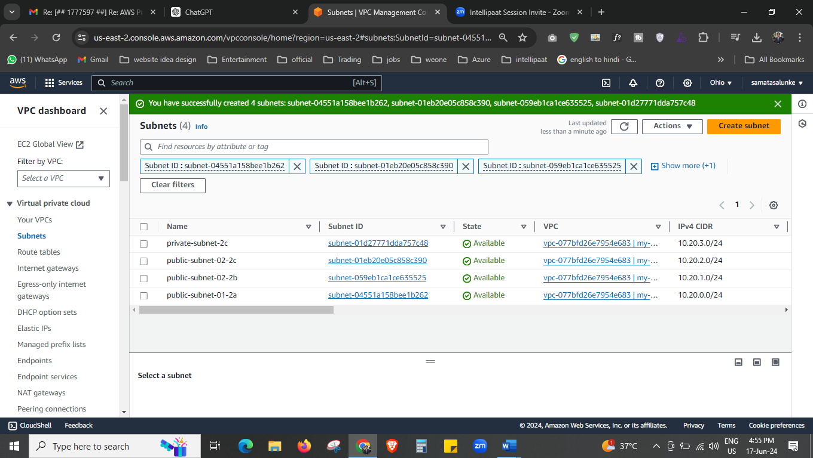



Create the 4 subnet 1 should be private and rest should be in public.

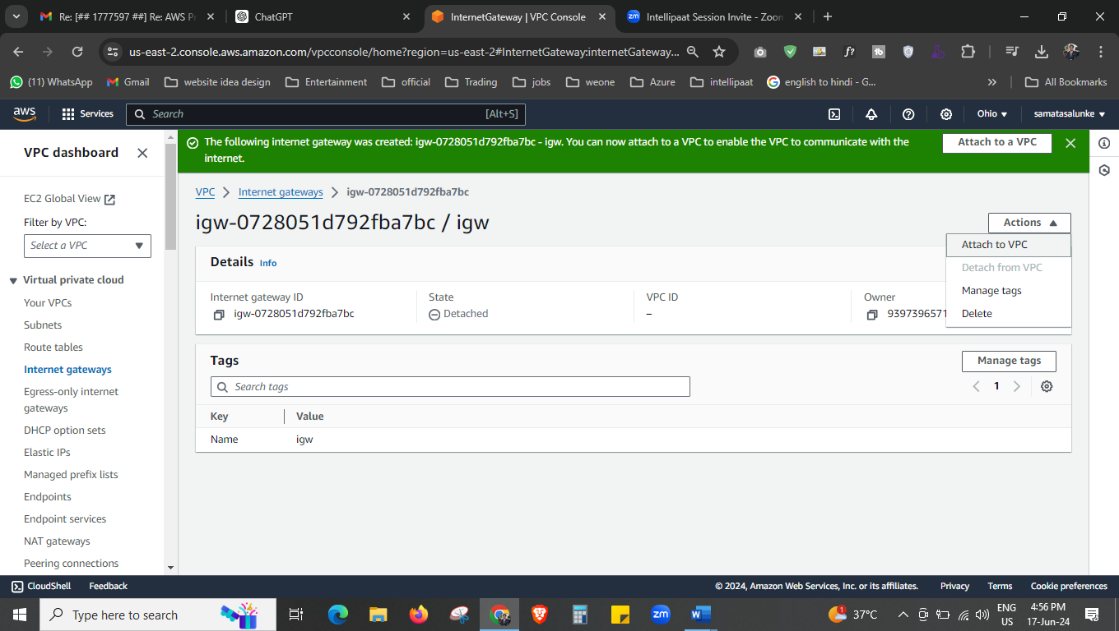



Create the internet gateway and attach to the vpc.

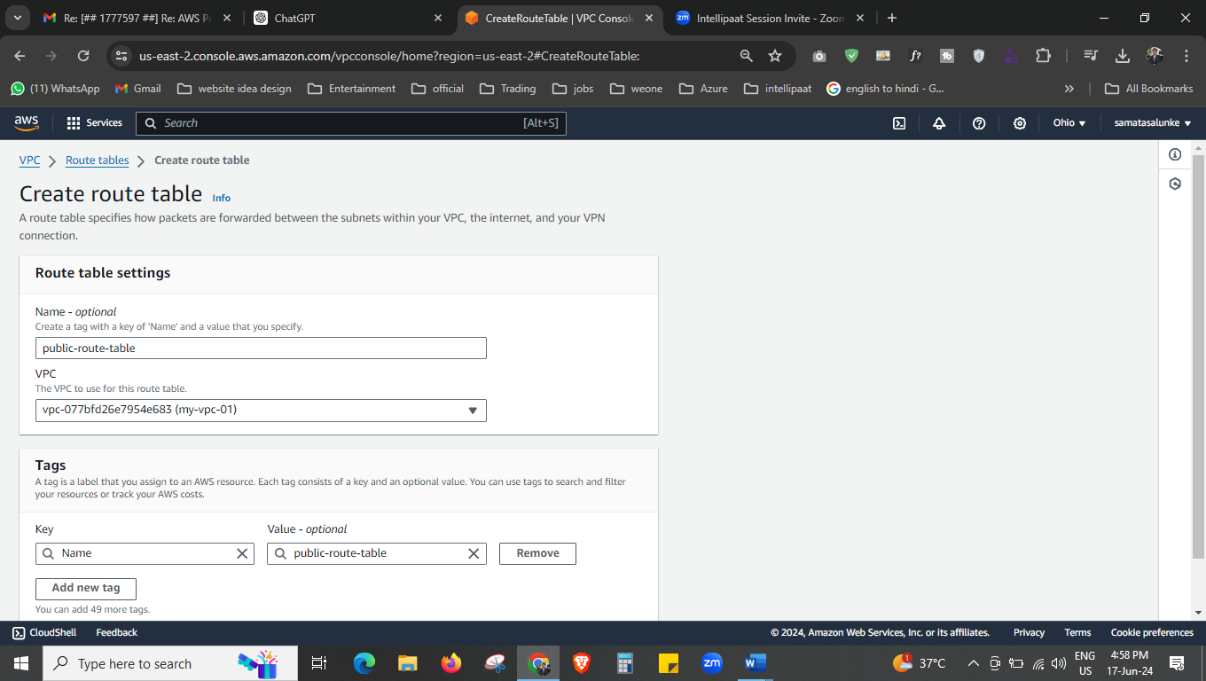



Create the public route table now,

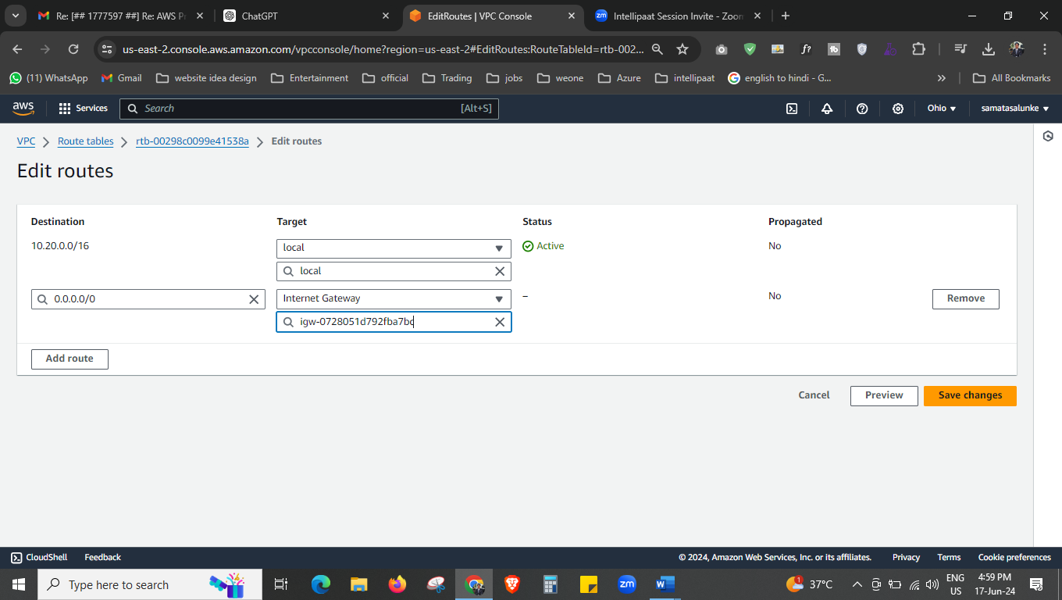



Add the internet gateway now to the route table.

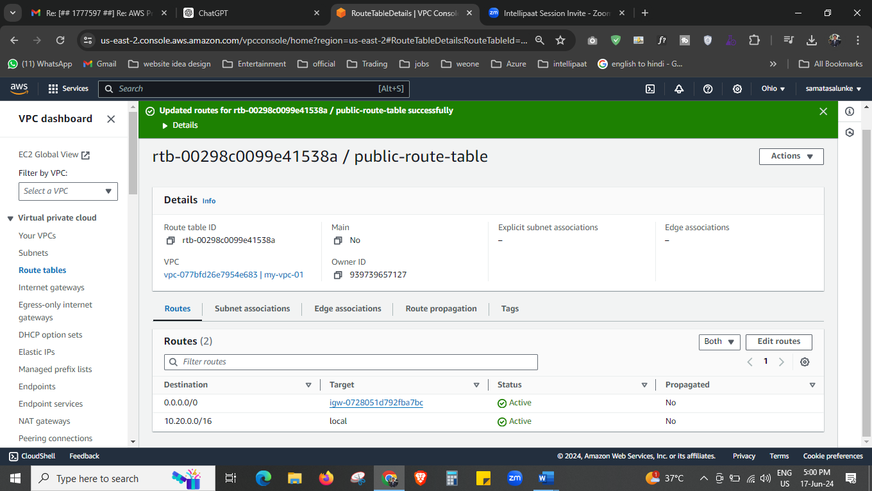



Allow it from 0.0.0.0.

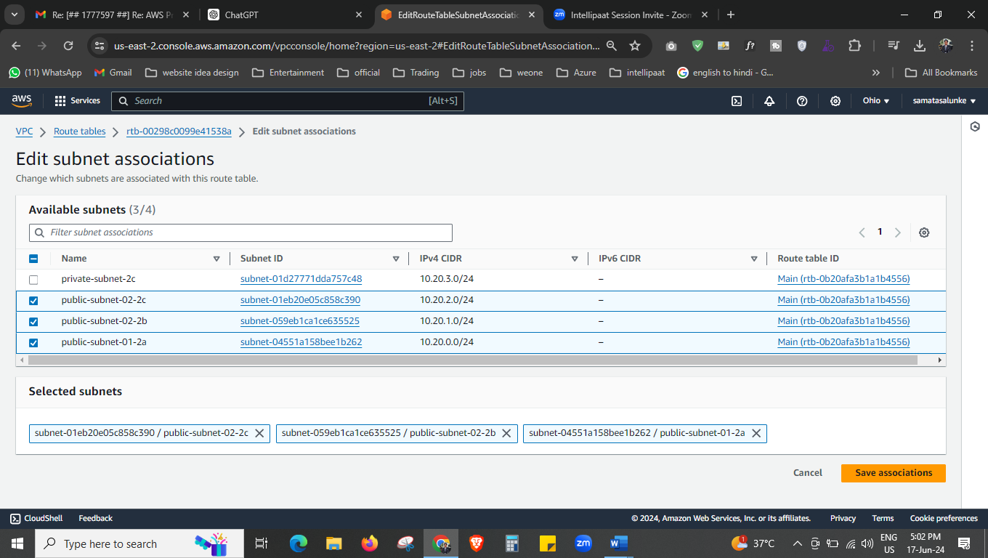



Add all public subnet to the subnet association.

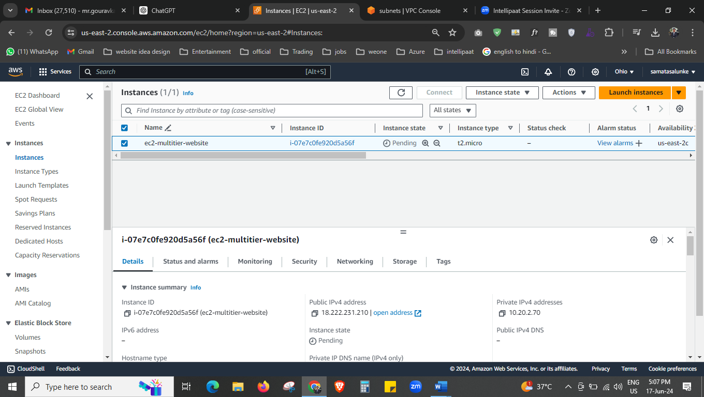



Create the ec2 instance and set the security group.

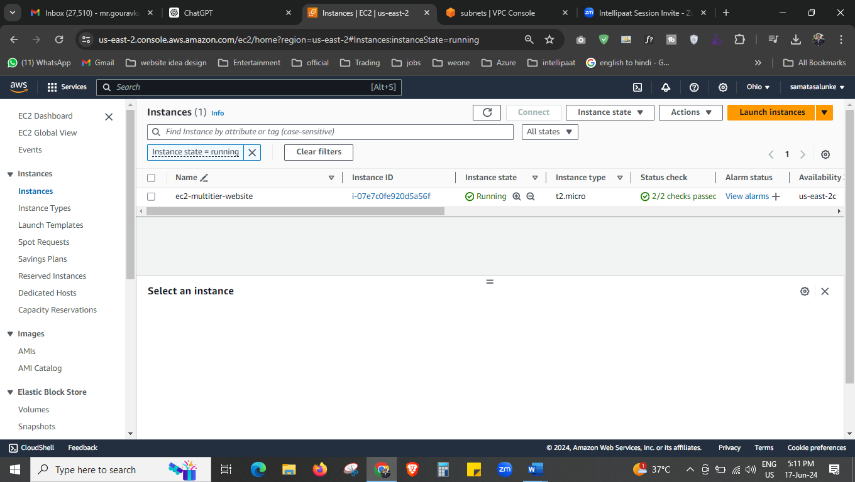

Create ec2 instance.

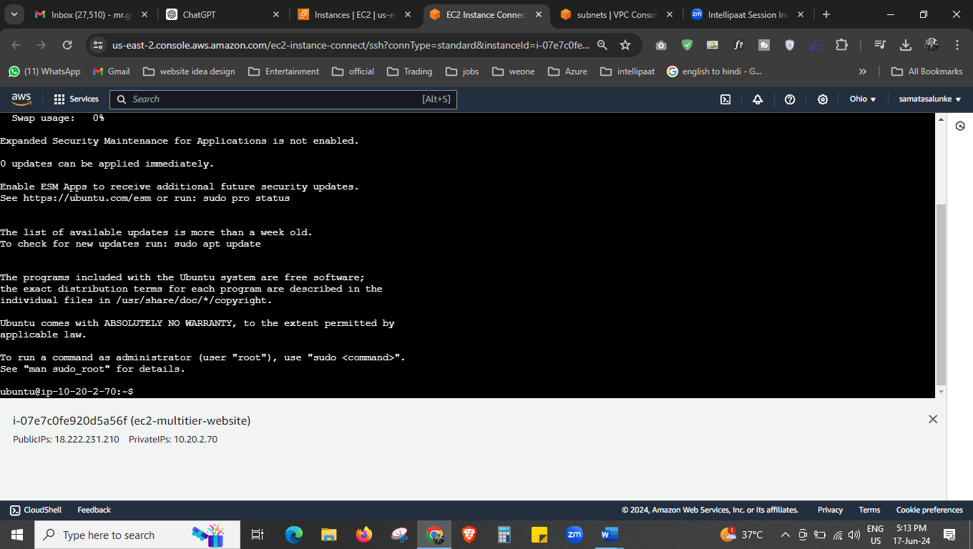



Open the ubuntu now.

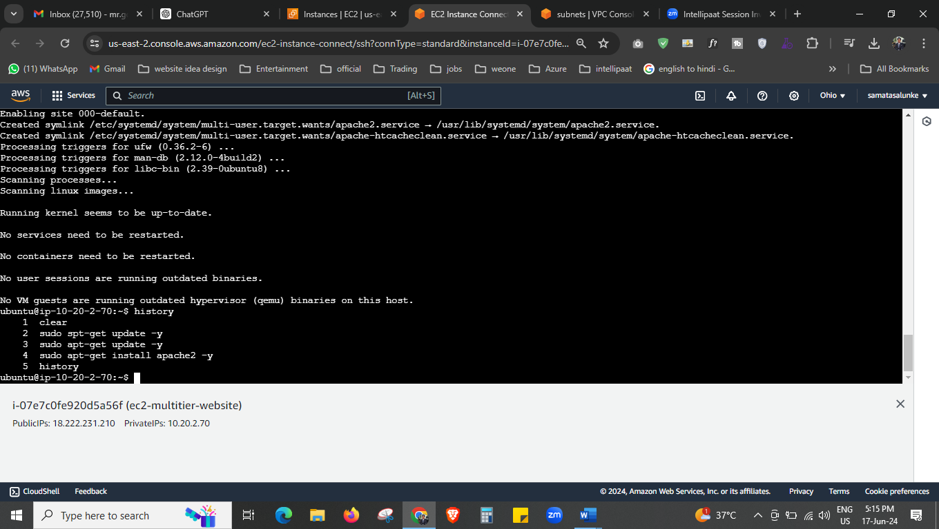



Here we installed apache 2 and update the machine.

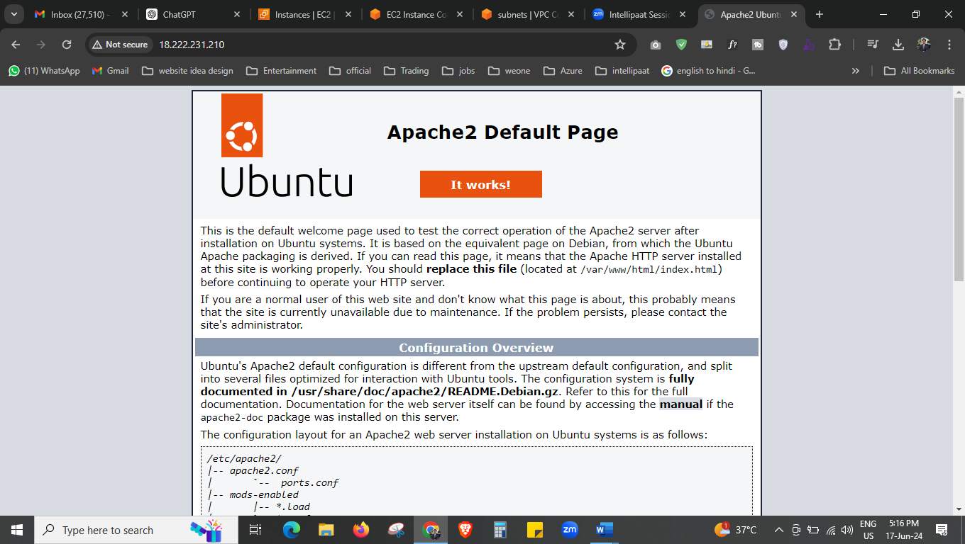

Here we run with public ip address.

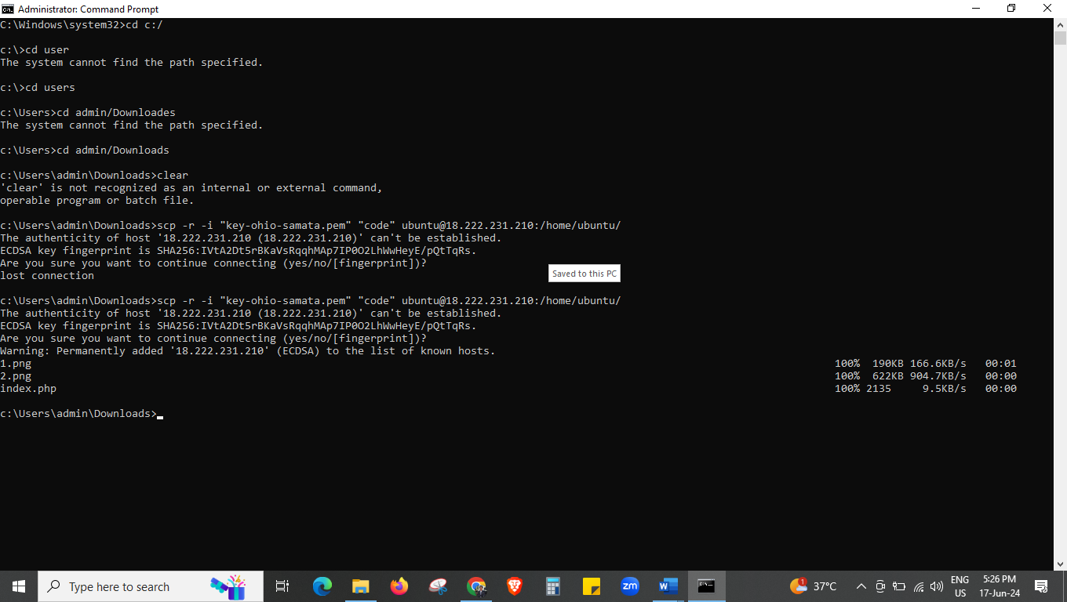



Open the command prompt and transfer the file that we have which contains all the code.

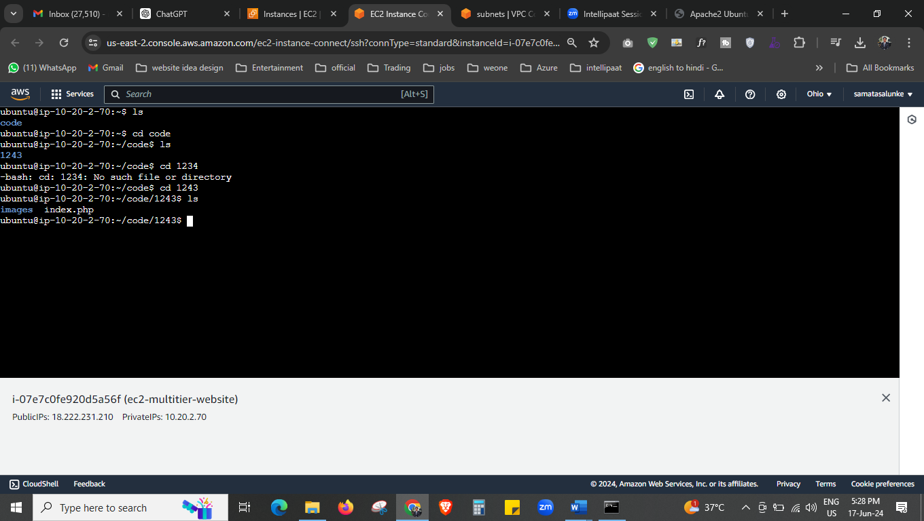



Here is our file that we just transferred.

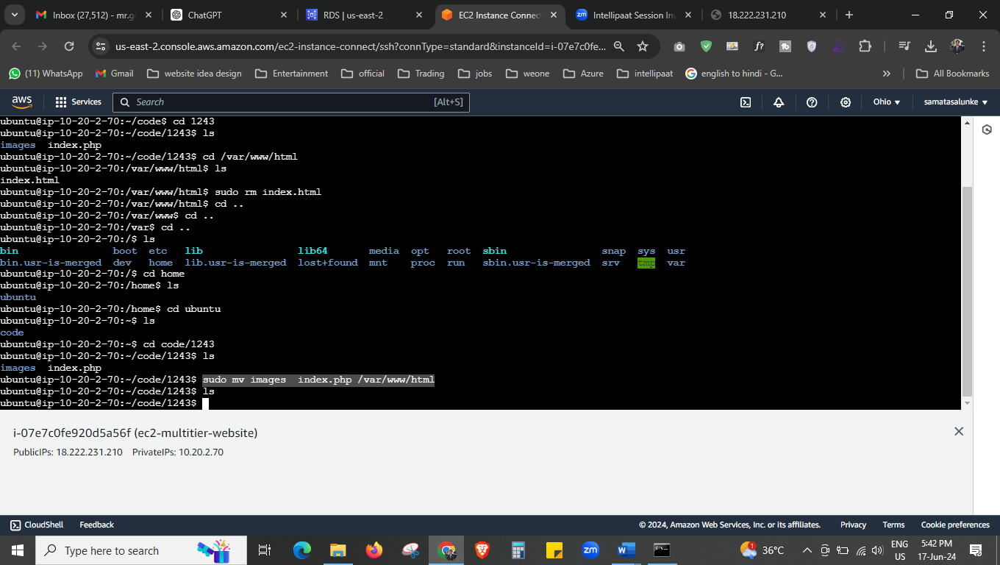



This tis location we moved our files.

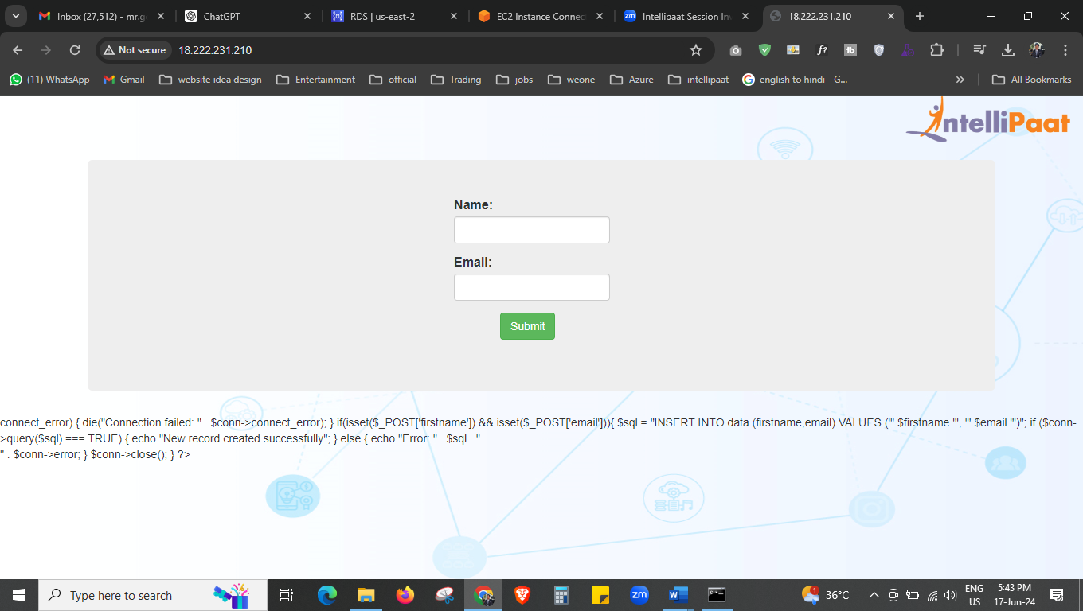



We have this output with error, now we will create the database and connect it.

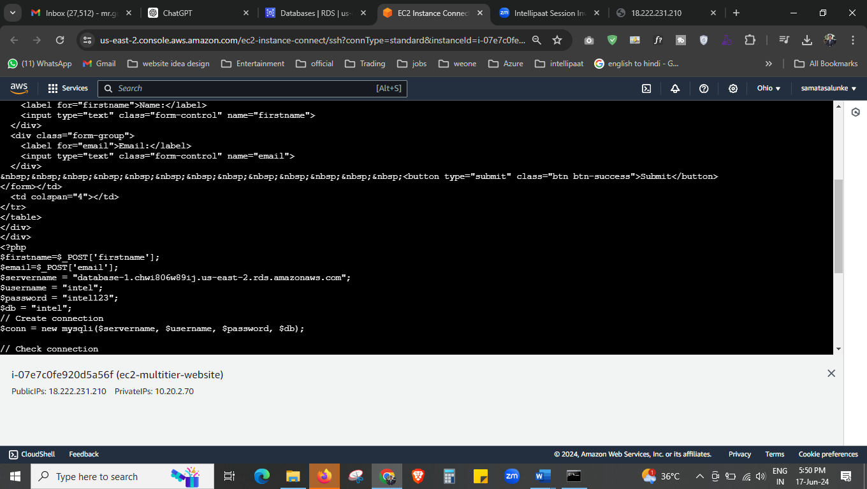



Copy paste your endpoint from RDS.

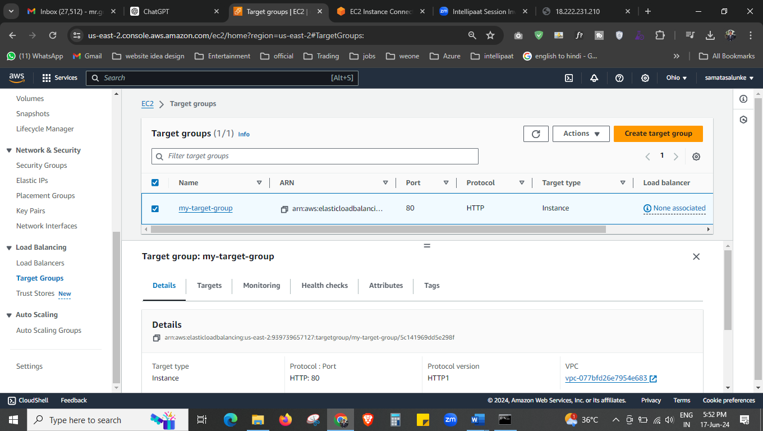

Our target group is done.

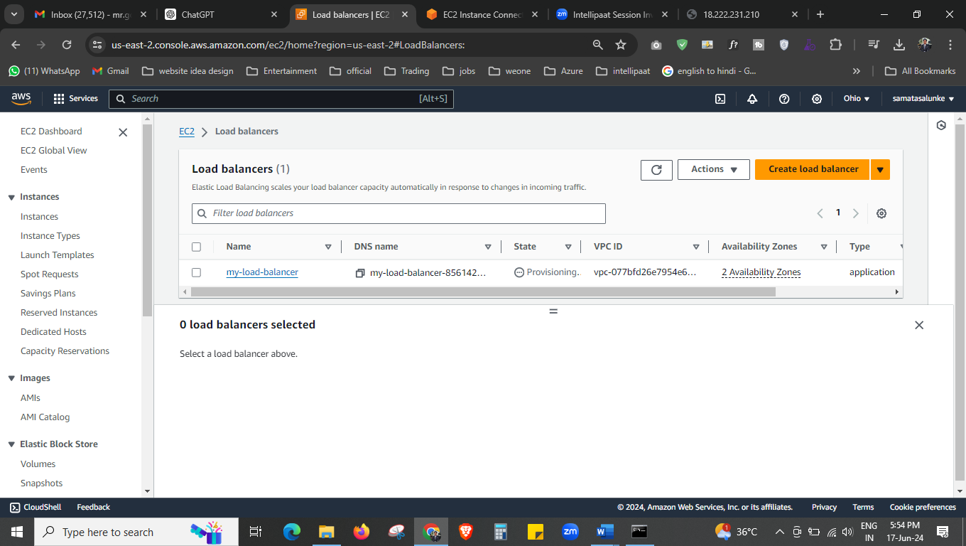

We created the load balancer now.

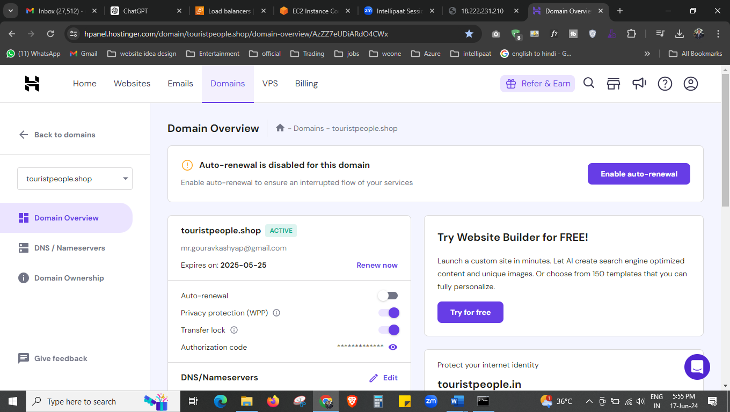



This is our domain we have purchased from the hostinger.

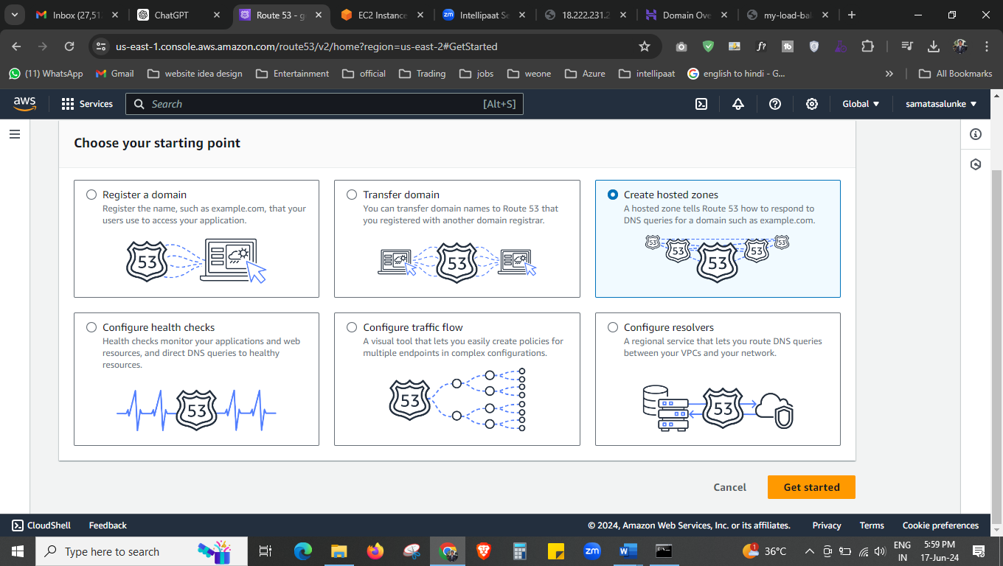



We will create the hosted zone now in route 53

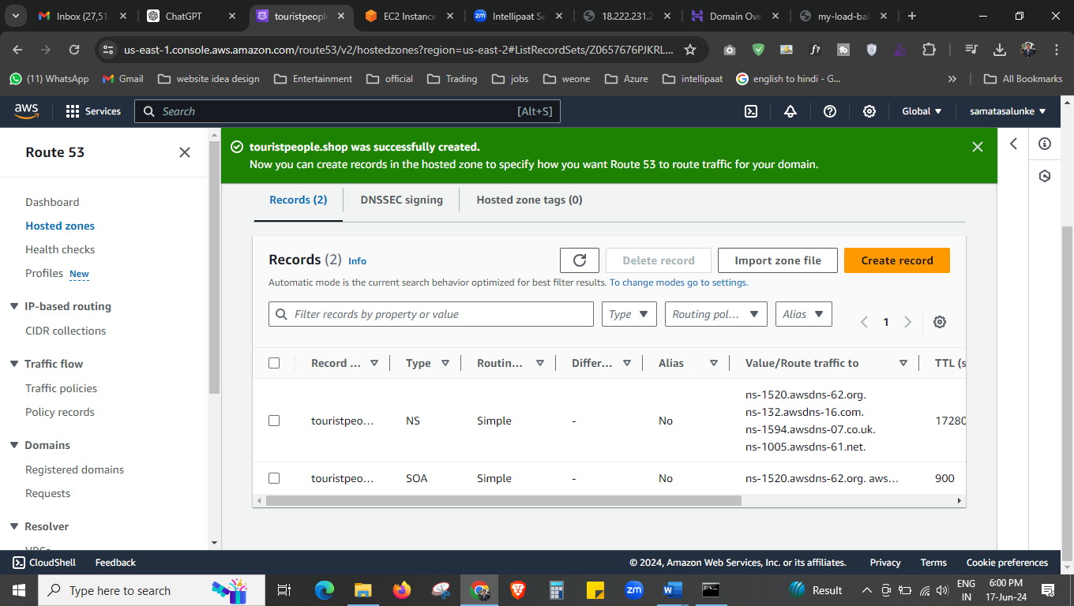



Our hosted zone is created now.

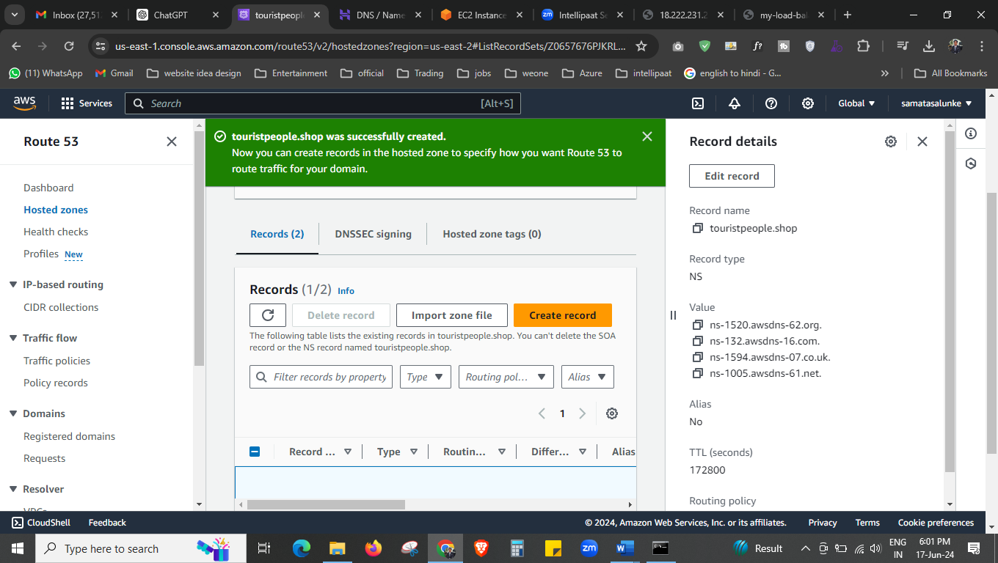



copy this hosted zone .

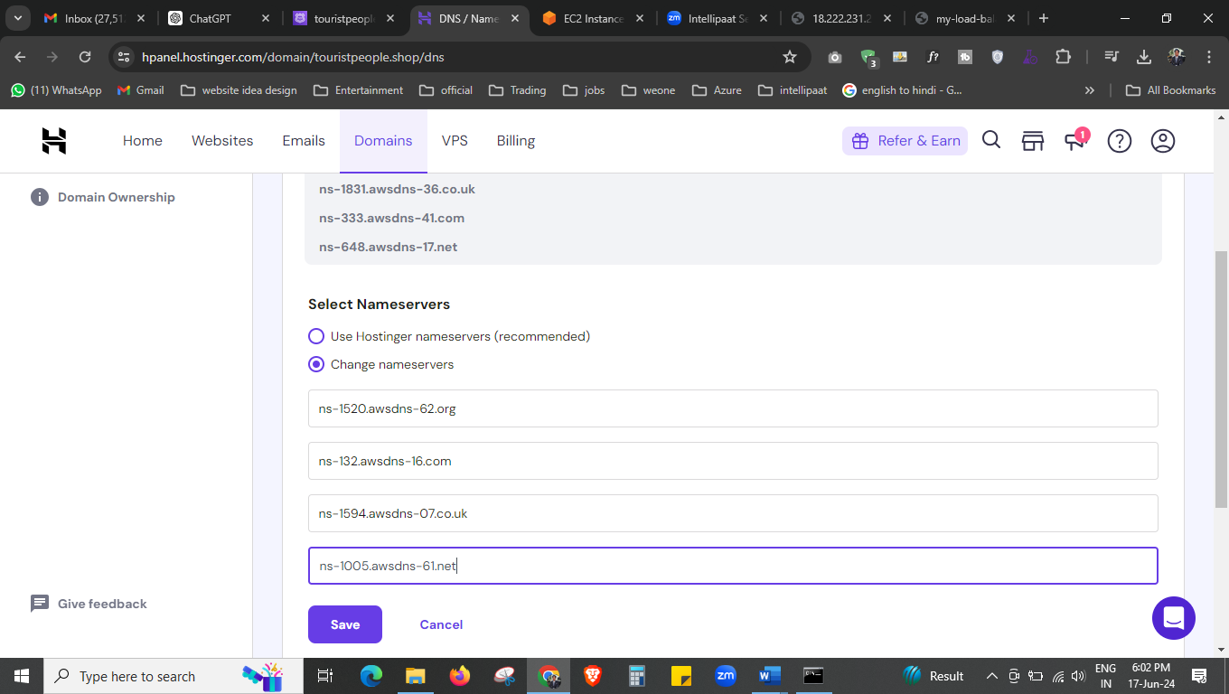



And add the hosted zone here.

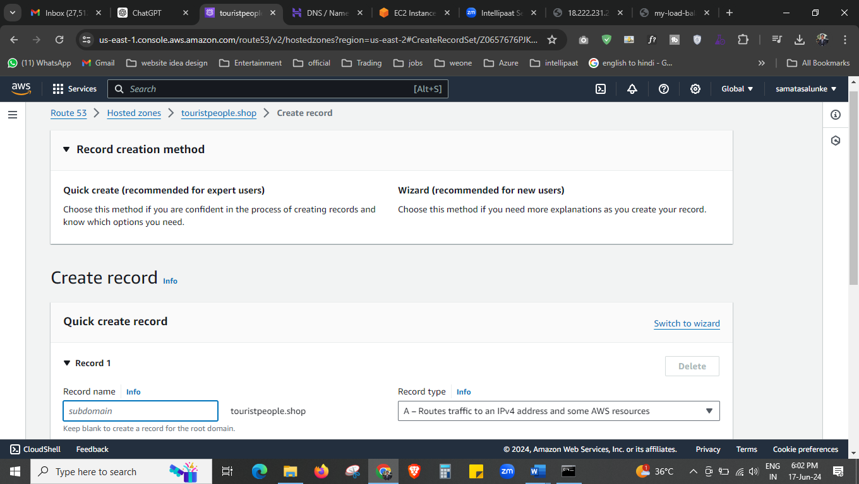

Now we will create the record so that we can add our loadbalancer there

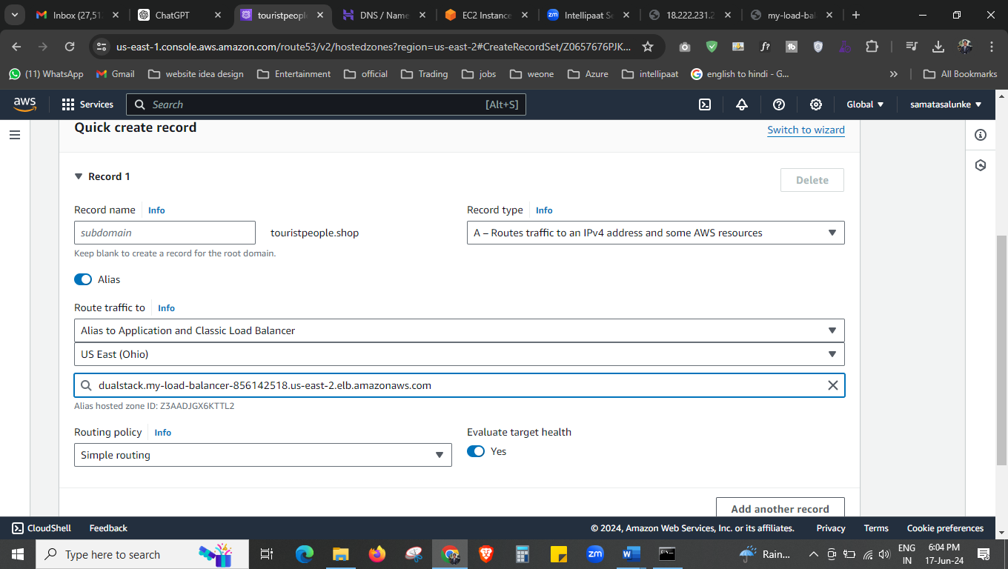



Here we add our load balancer.

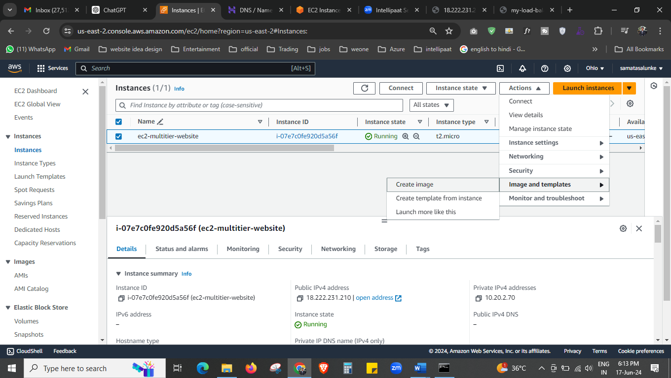

Now to make the autoscaling we have to create the AMI, launch template,

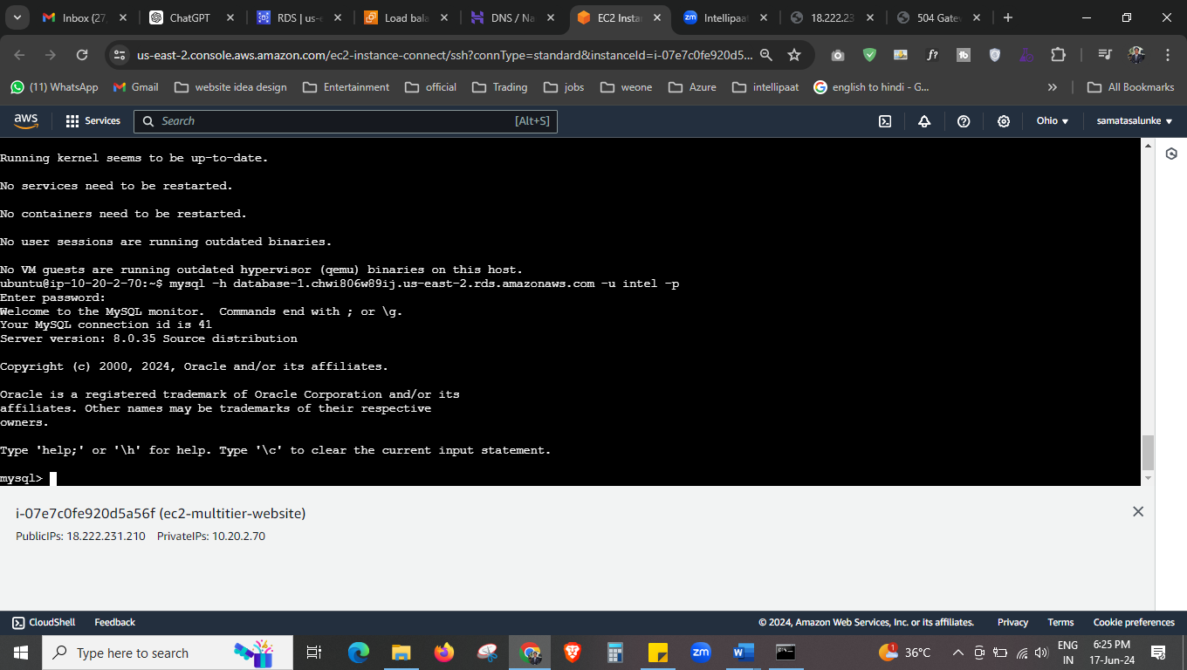



First we installed the msql and php

Here we done our installation.

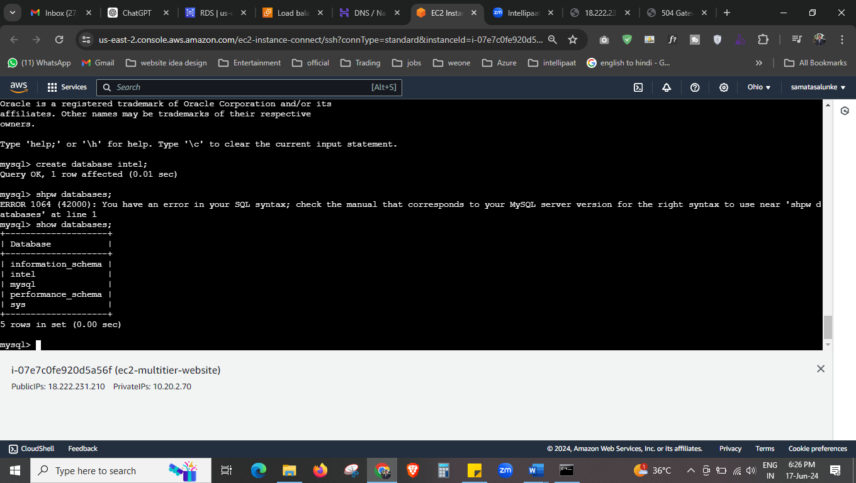

Our database is created now.

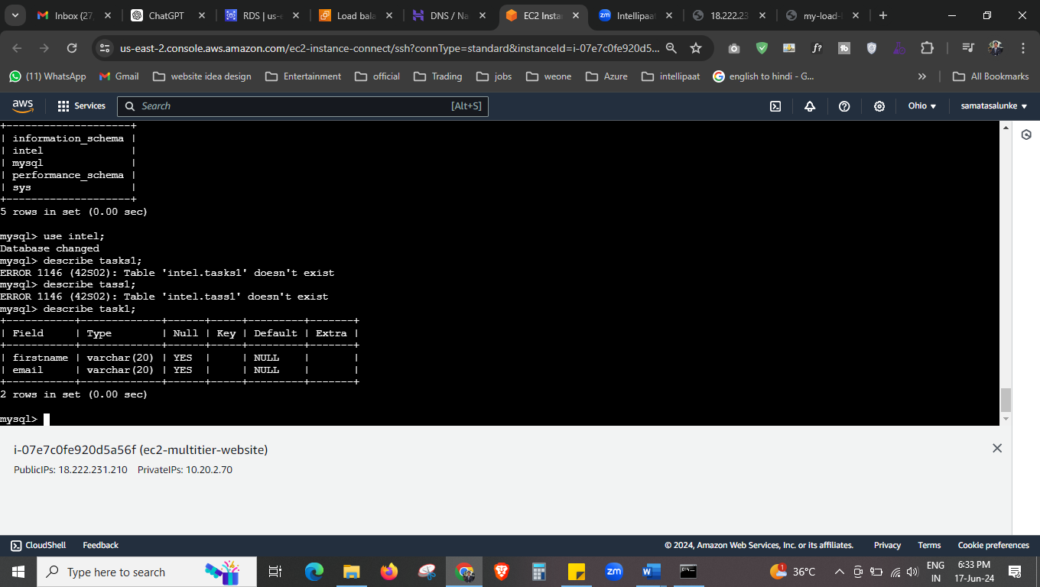

Here you can see the data base is showing the table.

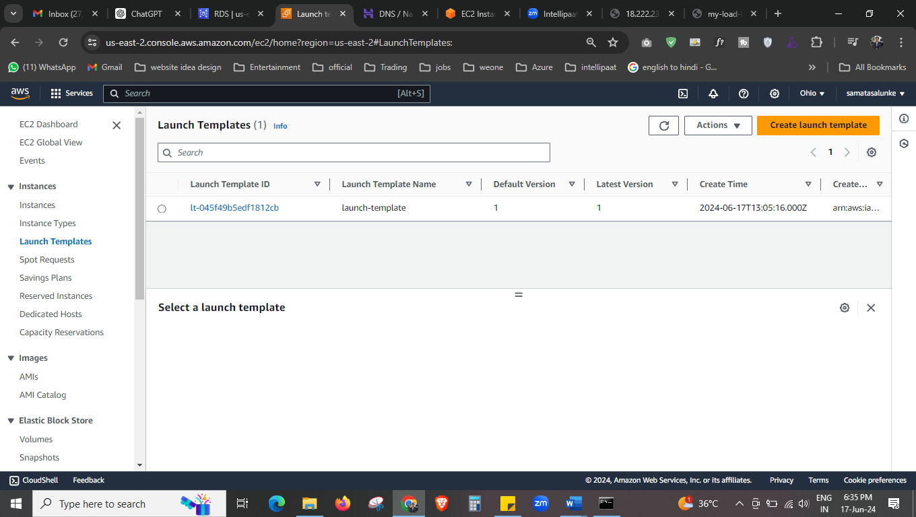

Here we create the launch template and auto scaling.

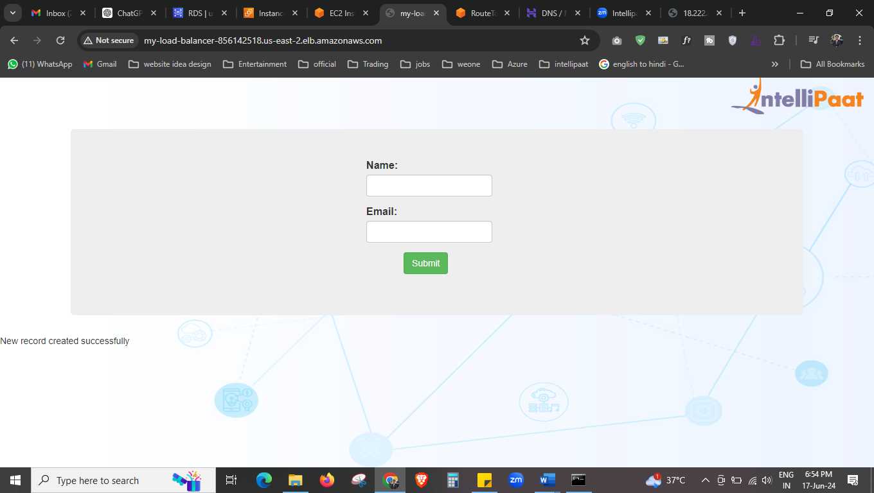



From load balancer DNS we able to submit the data, now this DNS will point to route 53 means our domain.

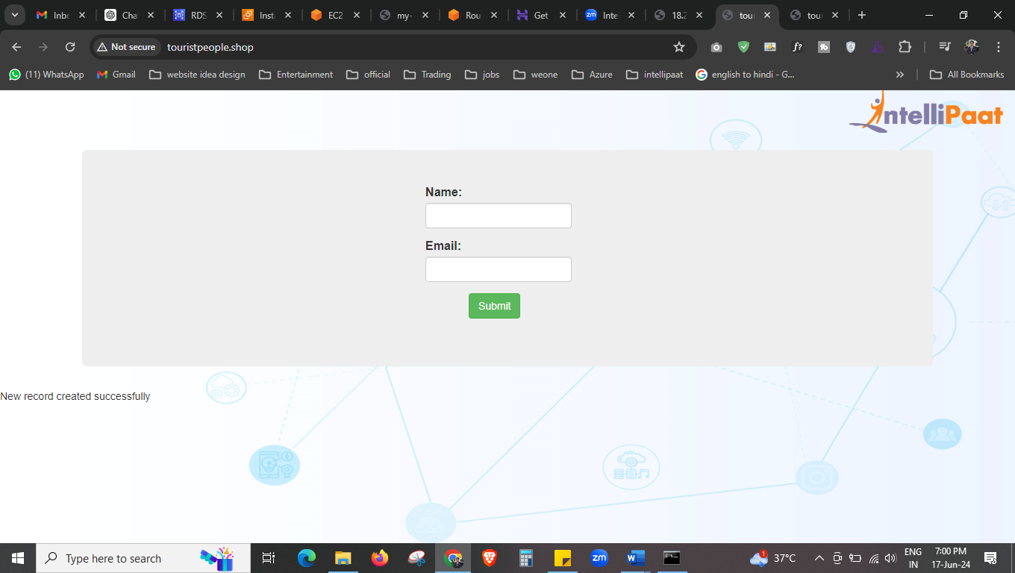



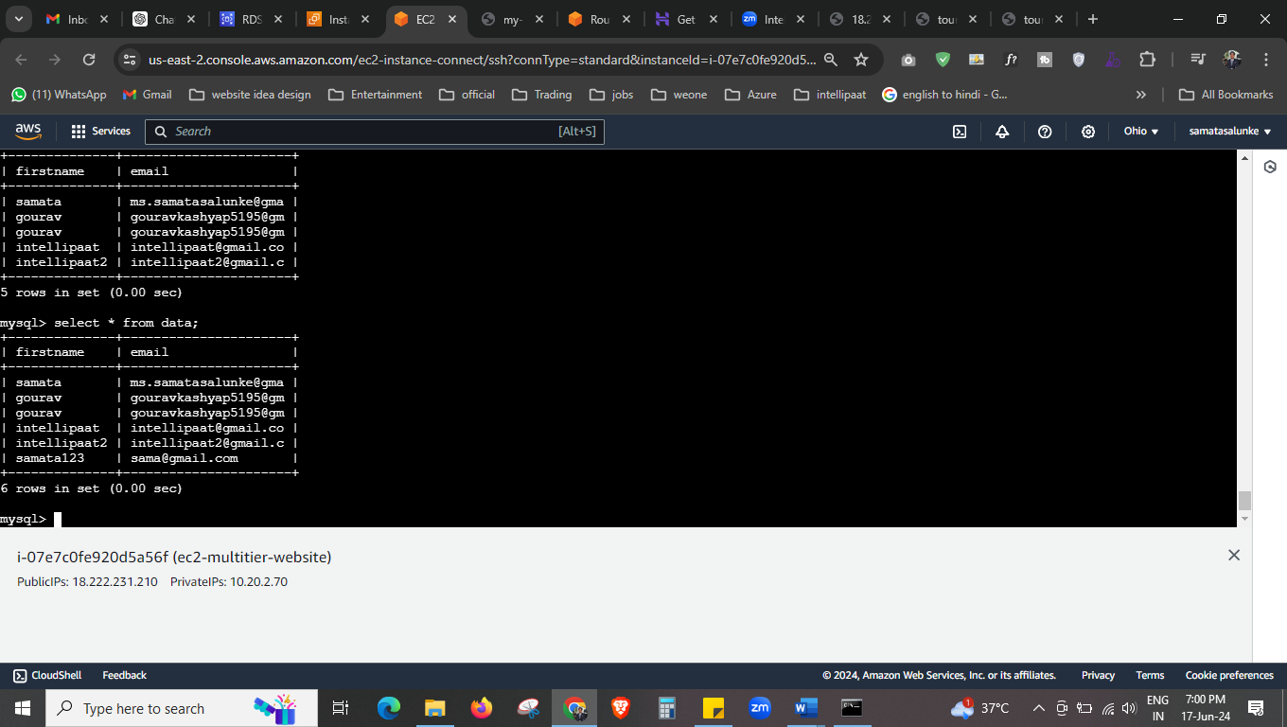



Our website is running successful and able to store our data in RDS database.

Command use for databases.

sudo add-apt-repository -y ppa:ondrej/php

sudo apt install php5.6 mysql-client php5.6-mysqli

mysql -h database-1.chwi806w89ij.us-east-2.rds.amazonaws.com -u intel -p

create database intel;

use intel;

create table data(firstname varchar (20), email varchar (20));